  - Weekly Assignments FROM THE DESK OF …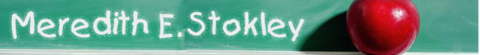AUGUST 2014
Mon: 18th | Tues: 19th | Wed: 20th | Thur: 21st | Fri: 22nd
Science

MAth

Social Studies

Reading

Projects

Other

